**DCU School of Computing   
 Assignment Submission**

|  |  |
| --- | --- |
| **Student Name(s):** | **Jordan Matthew Voss** |
| **Student Number(s):** | **17327513** |
| **Programme:** | **BSc in Computer Applications** |
| **Project Title:** | **SSADM Project** |
| **Module code:** | **CA214** |
| **Lecturer:** | **Renaat Verbruggen** |
| **Project Due Date:** | **10/12/2018** |

|  |
| --- |
| **Declaration**  **I declare that this material, which I now submit for assessment, is entirely my own work and has not been taken from the work of others, save and to the extent that such work has been cited and acknowledged within the text of my work. I understand that plagiarism, collusion, and copying is a grave and serious offence in the university and accept the penalties that would be imposed should I engage in plagiarism, collusion, or copying. I have read and understood the Assignment Regulations set out in the module documentation. I have identified and included the source of all facts, ideas, opinions, viewpoints of others in the assignment references. Direct quotations from books, journal articles, internet sources, module text, or any other source whatsoever are acknowledged and the source cited are identified in the assignment references.**  **I have not copied or paraphrased an extract of any length from any source without identifying the source and using quotation marks as appropriate. Any images, audio recordings, video or other materials have likewise been originated and produced by me or are fully acknowledged and identified.**  **This assignment, or any part of it, has not been previously submitted by me or any other person for assessment on this or any other course of study. I have read and understood the referencing guidelines found at**[**http://www.library.dcu.ie/citing&refguide08.pdf**](https://websvc.dcu.ie/%22http:/www.library.dcu.ie/citing&refguide08.pdf/%22)**and/or recommended in the assignment guidelines.**  **I understand that I may be required to discuss with the module lecturer/s the contents of this submission.**  **I/me/my incorporates we/us/our in the case of group work, which is signed by all of us.**  **Signed:__Jordan Voss____________** |

**Business Activity Model**

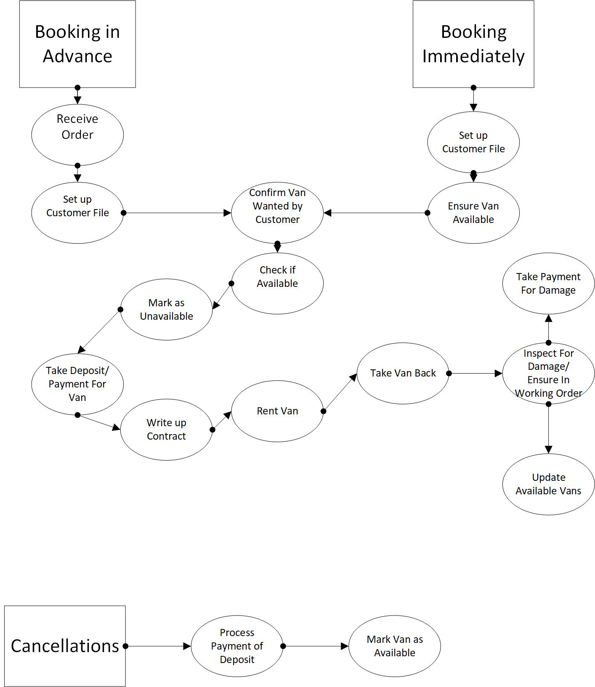

**Logical Data Model**

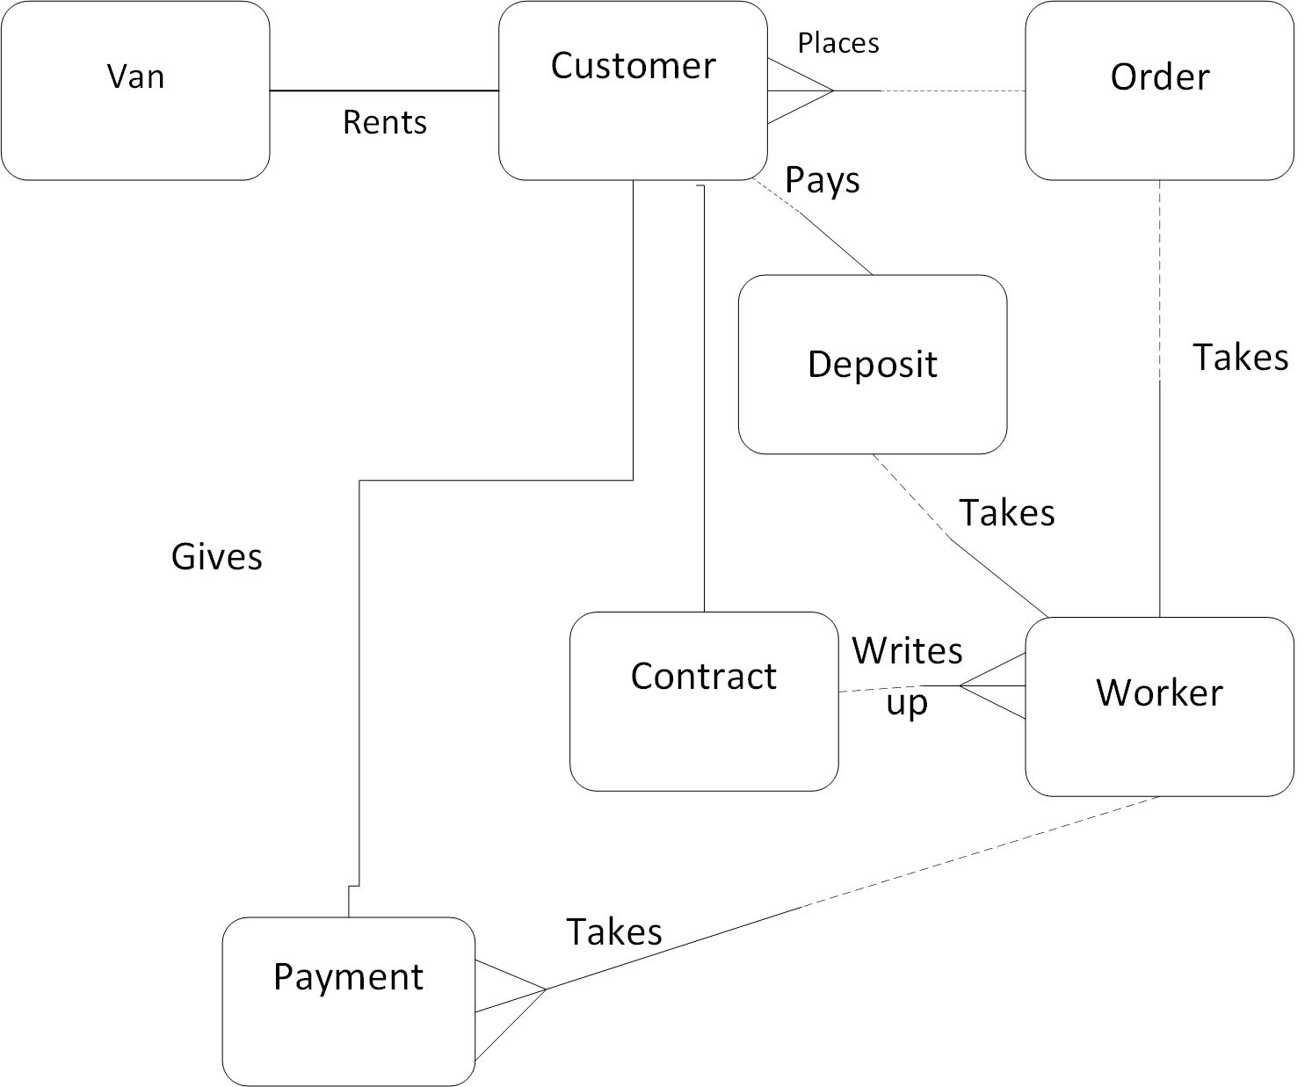

**Top Level Context Diagram**

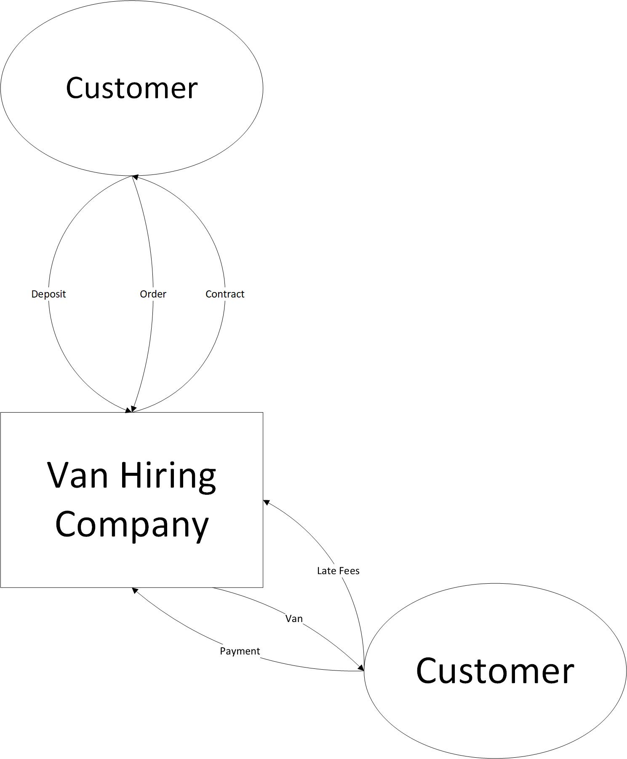

**Document Flow Diagram**

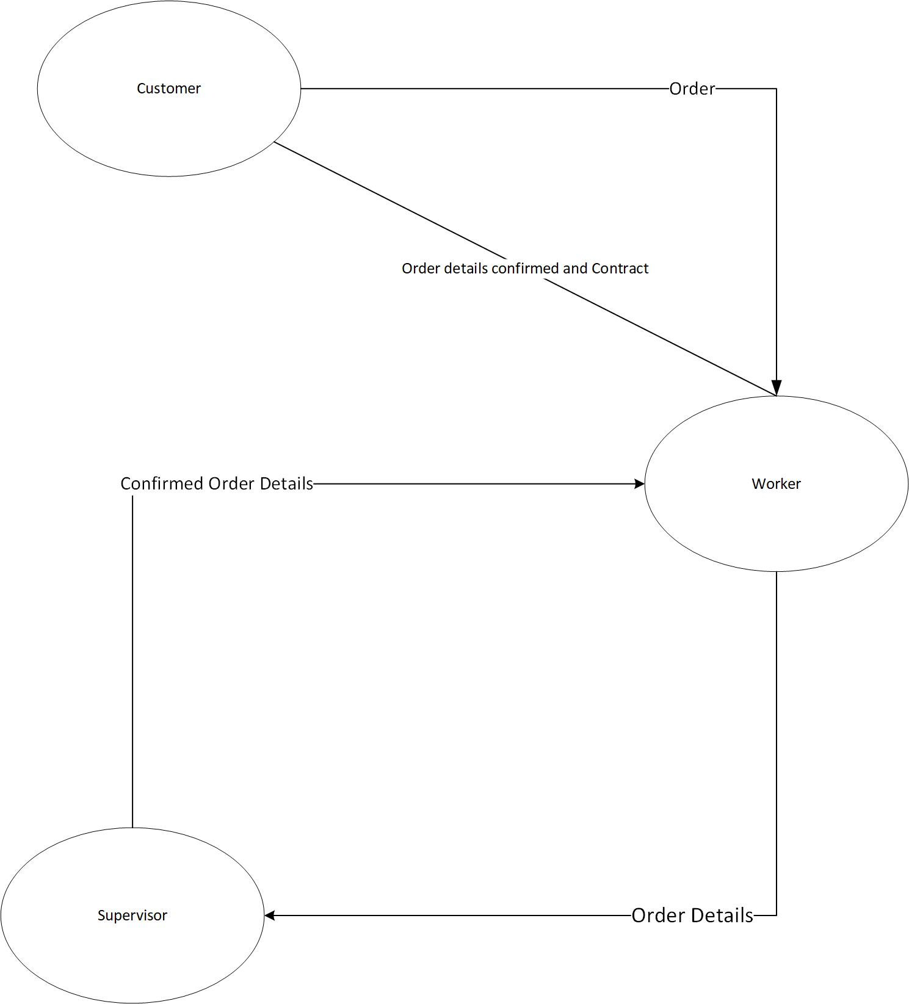

**Data Flow Diagram Level 1**

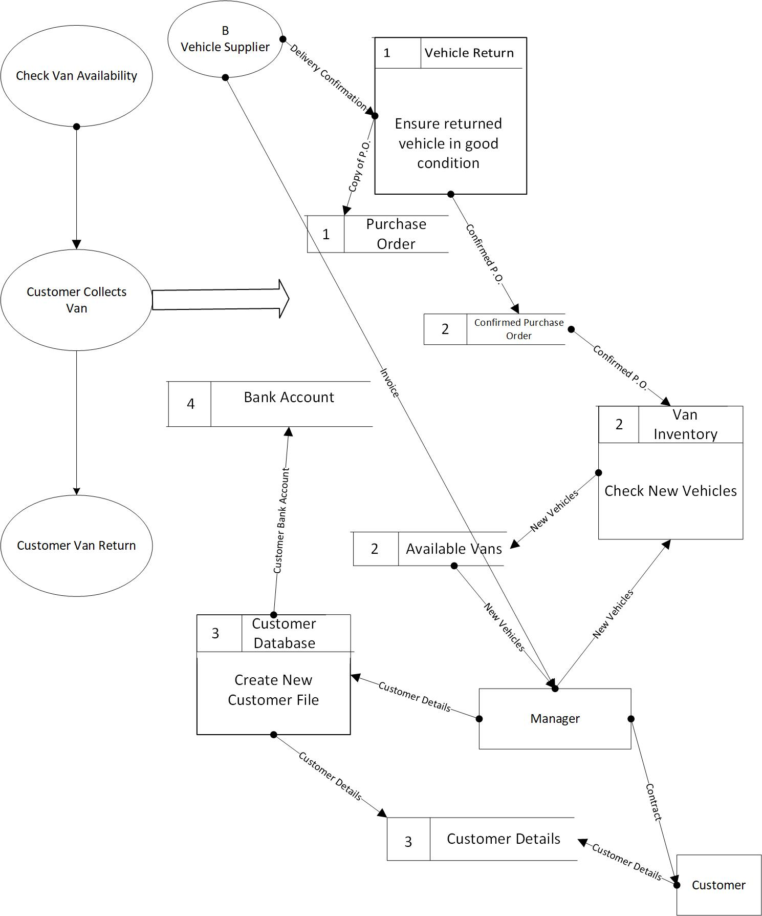

**Data Flow Diagram Level 2 (1)**

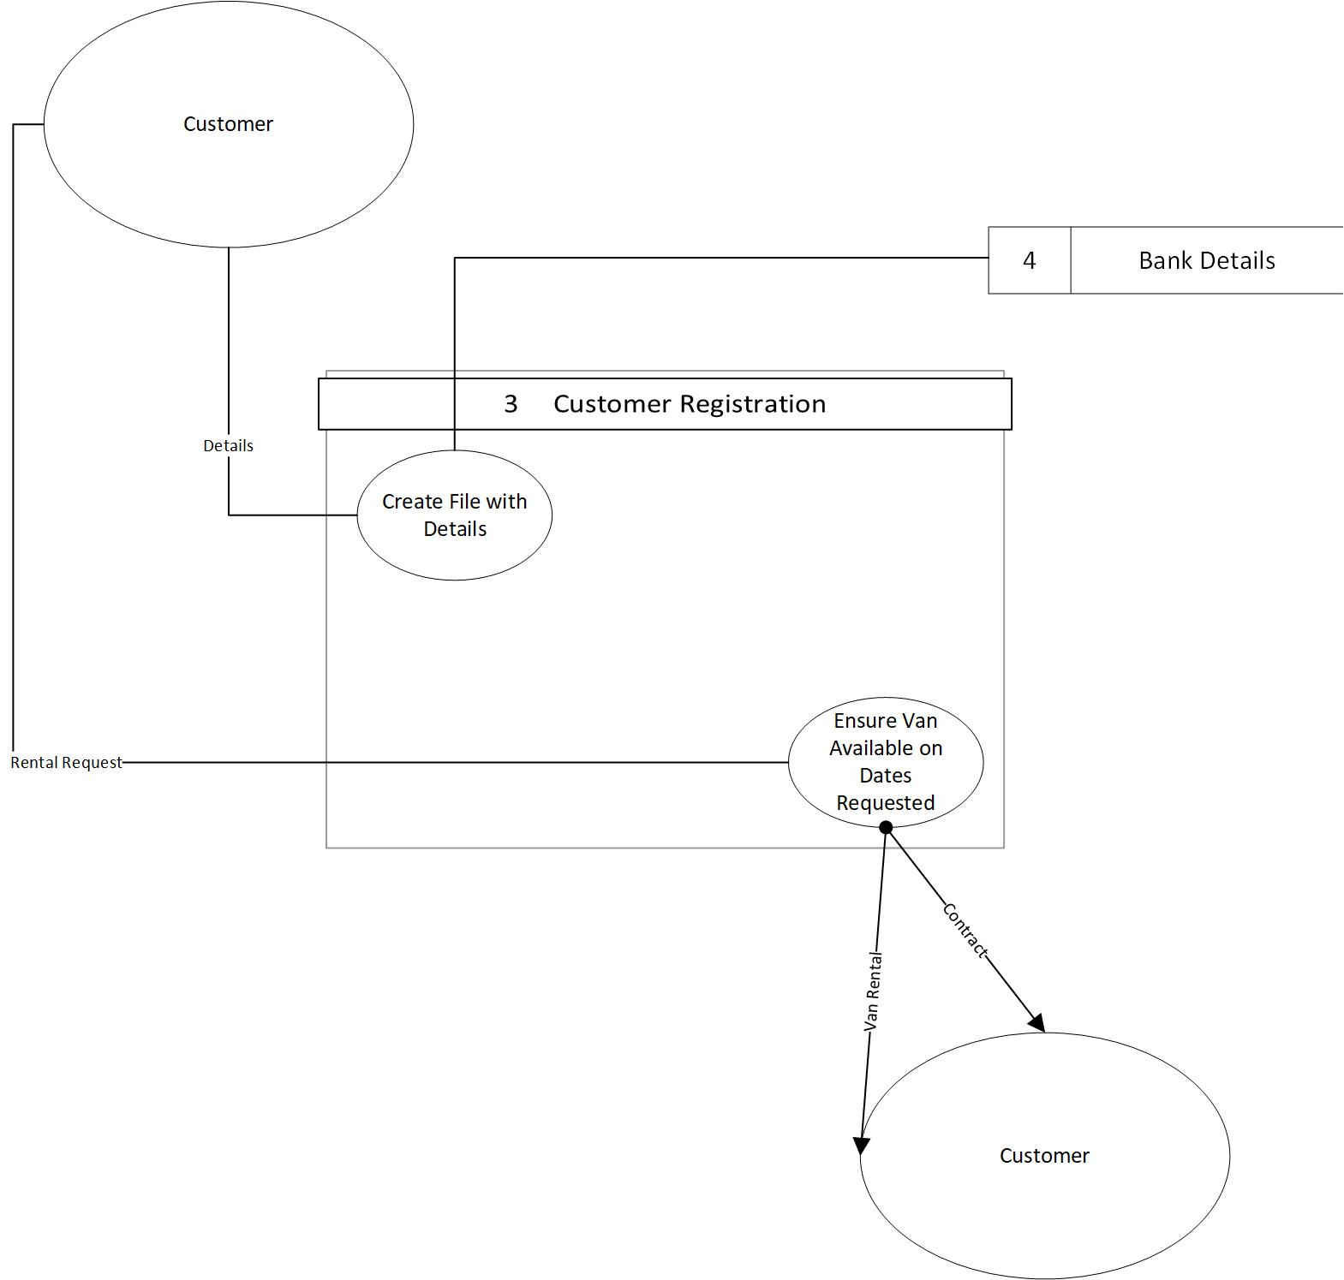

**Data Flow Diagram Level 2 (2)**

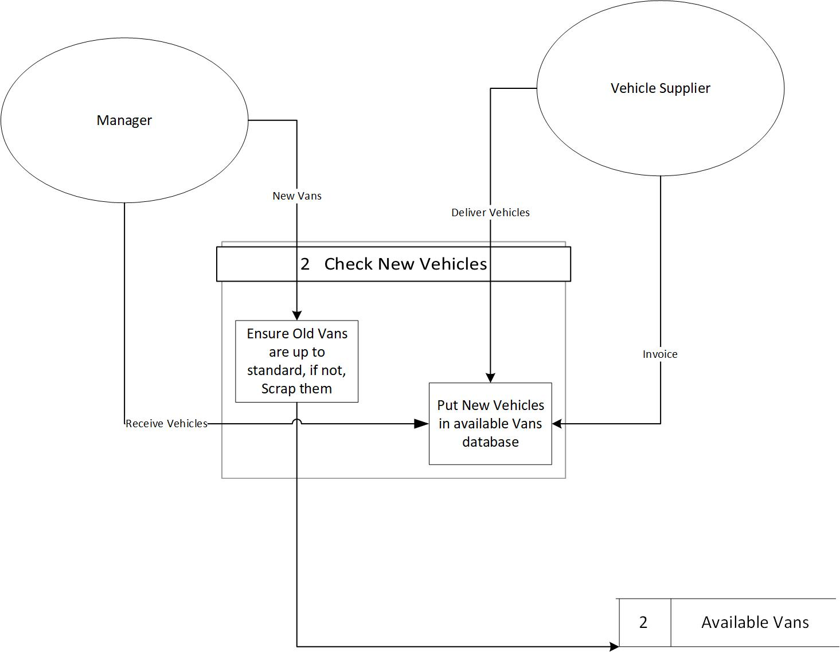

**Logical Flow Diagram (1)**

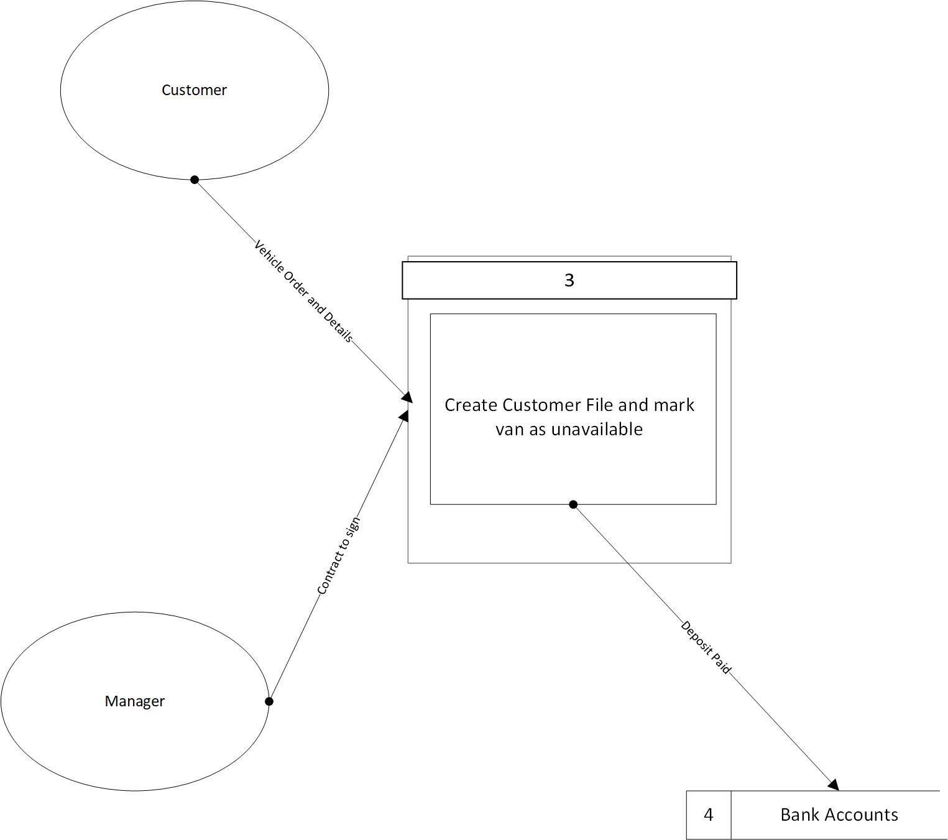

**Logical Flow Diagram (2)**

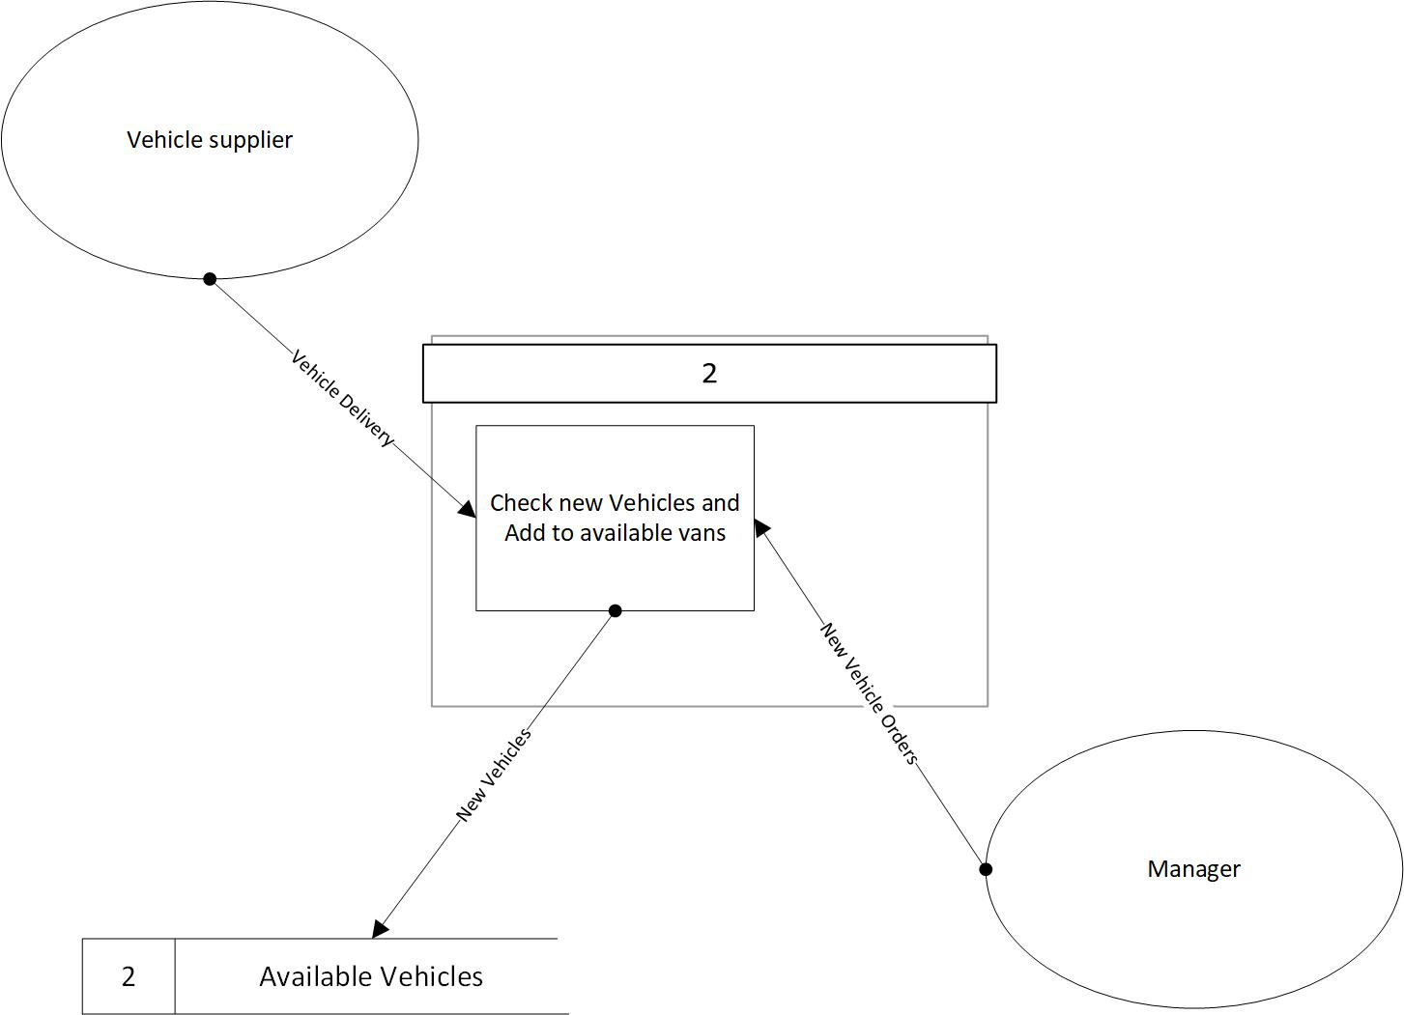

**Definitions:**

1. **Check Vehicle Received (DFD Level 1)**

This function is used to inspect the vans when they are returned by the customers. The mechanic will inspect the inner workings and an employee can easily inspect the outside for any visible damage. Visible damage and/or inner damage with the engine etc. will demand a damages fee paid by the customer on top of the deposit and payment already made.

1. **Create New Customer File (DFD Level 1)**

This Function is used to store all of the customer’s details including, name, address, phone number, whether deposit is paid or not, and rental history. This will enable the company to see if this customer has rented before and if they have a good record of bringing vans back on time and undamaged.

**I/O Diagram**

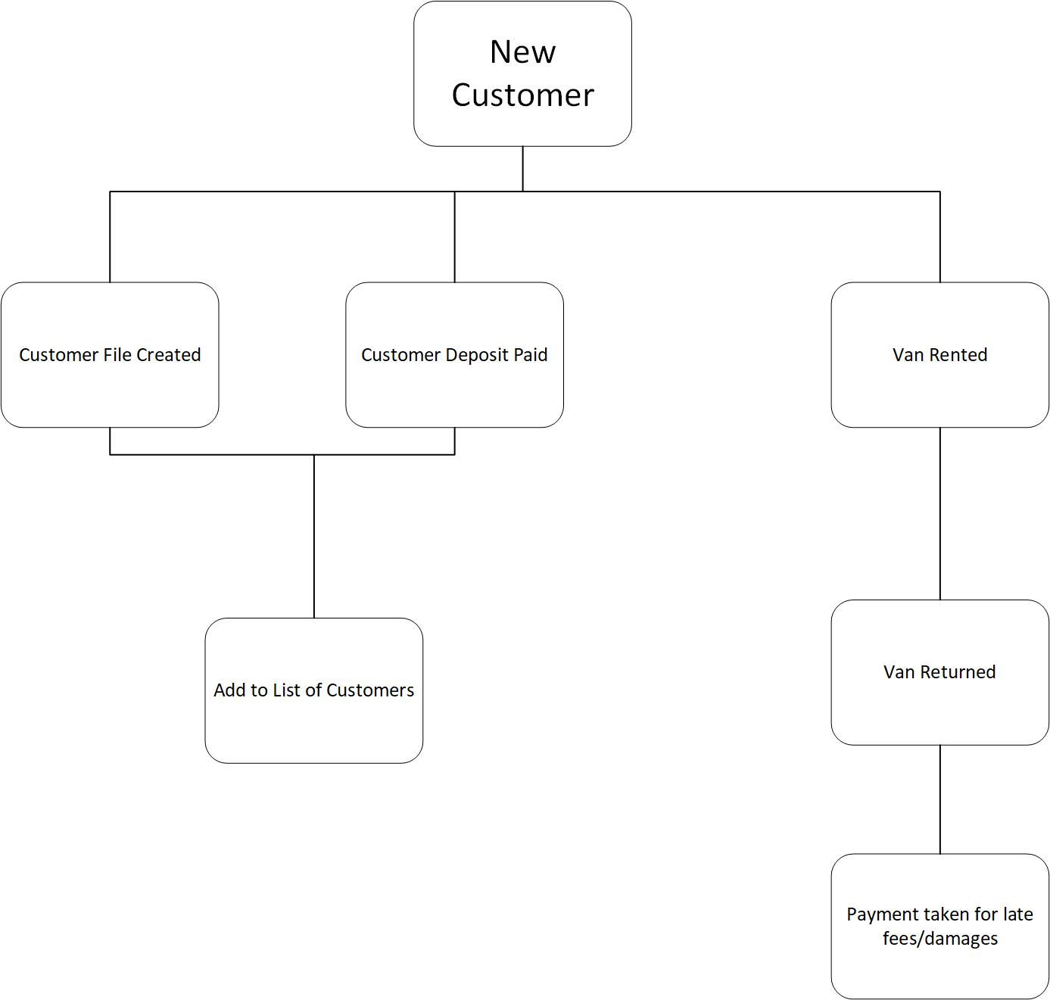

**Process Descriptions**

1. **Van availability for customer**

Ensure the customer has paid the deposit and make sure the van requested is free.

Ensure the van is in proper working order

Make sure the van is at the hire centre on time for customer collection

If the van isn’t available offer a different model of van in the same price range

1. **Take Customer Bookings**

Ensure Deposit Paid

Create/ Add to customer File

Lodge deposit to account

Issue contract

Once signed prepare van

**Data Flow**

|  |  |  |  |  |
| --- | --- | --- | --- | --- |
| **Data Flow Title** | **Origin** | **Destination** | **Data Content** | **Comments** |
| **Receiving Vehicle** | **Vehicle Supplier** | **Orders Confirmed** | **Vehicle Info** | **Added to available/unavailable vehicles** |
| **Customer Files** | **Manager** | **Bank** | **Customer Info** | **Update Customer File** |

**Entity Description**

|  |  |  |
| --- | --- | --- |
| **ID** | **Name** | **Description** |
| 4 | Bank | Holds all funds for company, takes deposits, payments, late fees, damages fees |

**Entity Description**

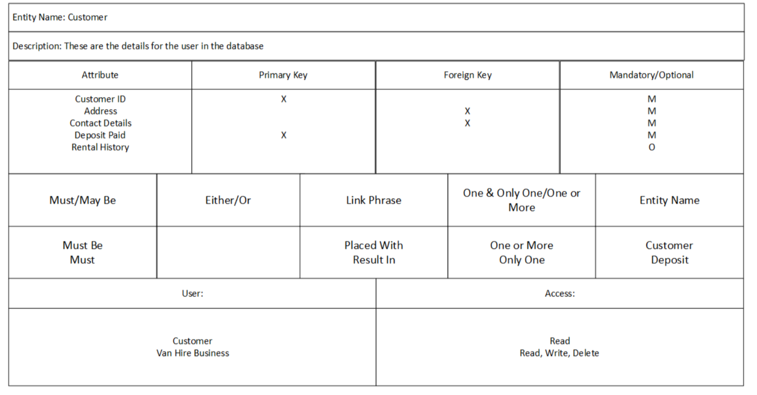

Yes

Yes

Yes

Yes

**Data Store**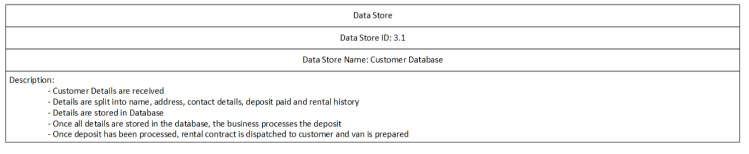

Customer File